

**Provisioning Template for AFM Policy Creation**

**User Guide**

|  |  |  |
| --- | --- | --- |
| **Version** | **Remarks** | **Date** |
| **1.0** | **Provisioning Template User Guide for AFM Policy creation.** | **18/01/2017** |
| **2.0** | **Updated document with installation of the template.** | **14/02/2017** |
|  |  |  |
|  |  |  |

## Installation of the Template and Helper Script

1. Login to AppViewX.
2. On the left navigation menu, select ***Provisioning***; and click ***Template.***
3. On the upper right portion of the screen click on the  Import button.
4. The following screen will appear. 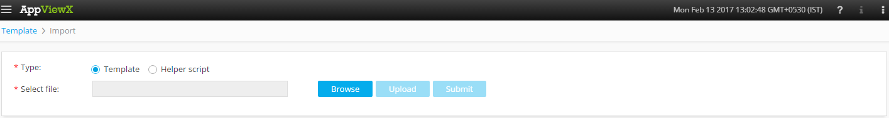
5. Please Select Template/Helper Script.  
   If Template is chosen,
   1. Click on *Browse* and select the Zip File of the template which has to be installed/imported and click open.
   2. Click on upload to import the Zip file and display the templates present in the zip file.
   3. Click on submit to deploy the templates into the AppViewX Environment.

If Helper Script is chosen,

1. Click on *Browse* and select the Zip File of the Helper script which has to be installed/imported and click open.
2. Click on upload to import the Zip file and display the Helper Scripts present in the zip file.
3. Click on submit to deploy the Helper Scripts into the AppViewX Environment.

## Creating AFM Policy

1. Login to AppViewX.
2. On the left navigation menu, select ***Provisioning***; and click ***Request.***
3. On the upper right portion of the screen, click the  ***Create*** button.
4. Select the provisioning template name from the list –‘**AFM Policy**’

**Note:** *If no template is available, this indicates that the user role does not have permission to the requesting template.*

1. Enter the provisioning request description – ‘*AFM Policy Creation*’.
2. Enter the Request Scenario Name relevant to the template. ***E.g***.: *AFM Policy Creation.*
3. In the Device version field, list of F5 device versions are populated. Please select the version of F5 device on which the AFM policy has to be created. Current Device versions which are supported by the template are V11 and V12
4. In the **Select Device** field, list of F5 devices are populated based on the version of F5 device. Please select the **F5** device on which the AFM policy has to be created.
5. In the **Select** **Partition** field, list of the available partitions are populated based on the *F5 device*. Please select the partition. ***E.g***.: Common.
6. In the **Rule Name** field, enter the relevant Rule name in the template.
7. Enter the Description relevant to the Rule name in the **Description Field**.
8. In the **Available Policy-Context** field, list of available policies are populated. Please select the required policy.
9. Select the **Source Address** as *Any* or *Other*.

IF **other** is selected, additionally fill these fields,

* 1. 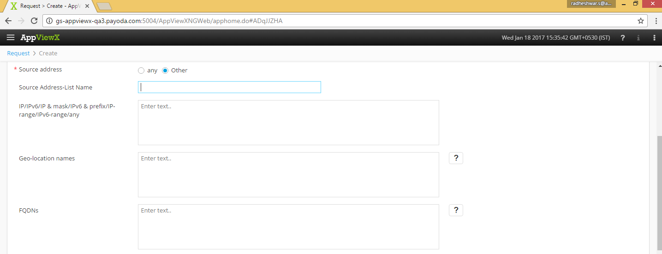In the **Source Address-List name** enter the Name of the Source Address-List.
  2. Enter the **IP/IPv6/IP & mask/IPv6 & prefix/IP-range/IPv6-range/any** in the field given. ***E.g***.: 22.22.33.11.
  3. In the **Geo-location names** enter the Geo location names ***E.g***.: AX.
  4. Enter the FQDNs (Fully qualified domain name) of the other source address.

If **any** selected the operations are continued

1. The list of **Vlan Name(s)** (Virtual LAN)are populated in the **Vlan Field,** select the required Vlan(s).
2. The list of relevant **Tunnel Name(s)** are populated in the **Tunnel Name field,** please select the appropriate Tunnel Name(s).
3. In the **Destination Address-List name** enter the Name of the Destination Address-List.
4. Enter the **IP/IPv6/IP & mask/IPv6 & prefix/IP-range/IPv6-range/any** in the field given. ***E.g***.: 22.22.33.11.
5. In the **Geo-location names** enter the Geo location names ***E.g***.: AX.
6. Please enter the FQDNs (Fully qualified domain name) of the Destination address.
7. Select the protocol from the given options (TCP, UDP or Others).

If **TCP/UDP** is selected,

* 1. Source Port Name has to be entered.
  2. Source Port Numbers/Range has to be entered.
  3. Destination Port Name has to be entered.
  4. Destination Port Numbers/Range has to be entered.

If **others** is selected,

* 1. Protocol Name/Number has to be entered.

1. Status of the Policy has to be selected from the list.
2. In the **User-List Name** Field, Enter the name of the User list.
3. In the **Domain Name\\User Name** Field Enter the Domain name and User Name in the Specified format. ***E.g***.: generic\\user.
4. In the **Action** Field, Select the action which has to be performed (Accept, Accept-Decisively, Drop, and Reject).
5. In the **Logging** field, select the option of logging the Events (Yes or No).
6. In the **Order** field, select the order in which the AFM policy has to be placed (Place-before or Place After).
7. In the **In-Depth Order** field, select the In-Depth order in which the AFM policy has to be placed (First, Last or Rule Name).
8. Click on *Submit* to generate work order(s) for the provisioning request.